

SIGN LANGUAGE DETECTION


Sign language detection system

Sign language detection | Graduation Project

FINAL YEAR GRADUATION PROJECT

Faculty Information Technology

Jadara University

Irbid, Jordan

SIGN LANGUAGE DETECTION
Sign language detection system

ALAA ASFA , 202110530

LOAY AlATAR , 202210843
ASAAD ABO ATEYEH , 202120257

Faculty Information Technology

Jadara University

Irbid, Jordan

Contact Information
This project report is submitted to the Department of Computer Science & Software Engineer at Jadara University in partial fulfilment of the requirements for the degree of Bachelor of Information Technology.

Author(s):
LOAY ALATAR, (202210843)
Address: Irbid
ALAA ASFA, (202110530)
Address: Irbid

ASAAD ABO ATEYEH, (202120257)
Address: Irbid

University supervisor(s):
Dr. Marah Qassas
Faculty of Information Technology
Jadara University
Jordan

Intellectual Property Right Declaration

This is to declare that the work under the supervision of Dr.Marah Qassas having title
“Sign language detection” carried out in partial fulfilment of the requirements of Bachelor of Information Technology, is the sole property of the Jadara University and the respective supervisor and is protected under the intellectual property right laws and conventions. It can only be considered/ used for purposes like extension for further enhancement, product development, adoption for commercial/organizational usage, etc., with the permission of the University and respective supervisor.

Date: 26/4/2026
Author(s):

Name:

Signature: _____________________

Signature: _____________________

ASAAD ABO ATEYEH, (202120257)

Name: ALAA ASFA, (202110530)
Name: LOAY ALATAR, (202210843)
Signature: _____________________

Supervisor(s):

Dr. MARAH ALQASSAS
Signature: _____________________

Anti-Plagiarism Declaration

This is to declare that the above publication produced under the supervision of Dr. MARAH ALQASSAS having title “Sign language detection” is the sole contribution of the author(s) and no part hereof has been reproduced illegally (cut and paste) which can be considered as
Plagiarism. All referenced parts have been used to argue the idea and have been cited properly.
I/We will be responsible and liable for any consequence if violation of this declaration is proven.

Date:

Author(s):

Name:ALAA ASFA

Name : LOAY ALATAR

Name: ASSAD ABO ATEYEH

ACKNOWLEDGMENTS

First of all, we would like to thank Dr. MARAH ALQASSAS for his guidance and feedback on this graduation project, which helped us to overcome many difficulties and made this system much more accurate and robust.

We also wish to acknowledge the Faculty of Information Technology in Jadara University for giving us the knowledge and tools necessary for the completion of this project.

project work.
At last, we would like to thank our families and friends for their support and help during our
-
Special Task Team ‘STT’

ABSTRACT

SIGN LANGUAGE DETECTION SYSTEM

Sign language is a key way for individuals with hearing and speech impairments to communicate. However, many people do not understand sign language. This creates barriers in education, public services, and everyday life. This graduation project presents a Sign Language Detection System Using Artificial Intelligence (AI). It recognizes hand gestures through a camera and shows the predicted meanings as text in real time.

The system is built using Python. It integrates OpenCV for capturing and processing images, MediaPipe Hands for precise landmark extraction, and machine learning with a Random Forest classifier for gesture classification. A desktop graphical user interface (GUI) is created with Tkinter, featuring a login module, a main menu for navigation, and a complete training pipeline that allows users to add new gestures without changing the underlying code. The training pipeline consists of data collection, feature extraction, and model training stages.

The detection module works in real time and includes a technique to smooth out predictions for greater stability. This system is designed to be scalable, easy to use, and affordable compared to sensor-based sign language solutions. It serves as an assistive communication tool and lays the groundwork for future improvements, such as speech output and mobile deployment.

Keywords: Sign Language, Gesture Recognition, Computer Vision, MediaPipe, OpenCV, Random Forest, AI, Tkinter.

TABLE OF CONTENTS
1. INTRODUCTION 11
1.1 PURPOSE OF THE SYSTEM: 11
1.2 PURPOSE OF THIS DOCUMENT: 11
1.3 OVERVIEW OF THIS DOCUMENT: 12
1.4 EXISTING SYSTEMS: ........................................................................................................ 12
1.4.1 EXISTING SYSTEM DESCRIPTION 12

1.4.2 PROBLEMS IN THE EXISTING SYSTEMS……….……………………………………………….12
- SYSTEM ANALYSIS. ............................................................................................................... 13
  - DATA ANALYSIS. .............................................................................................................. 13
2.1.1 DATA FLOW DIAGRAM……………………………………………………………………………….14

2.1.2 SYSTEM REQUIRMENTS……………………………………………………………………………..17
2.1.2.1 USE-CASE DIAGRAM………………………………………………………………………17
2.1.2.2 LIST OF FUNCTIONAL AND DATA REQUIREMENT…………………………..19

2.1.2.3 LIST OF NON-FUNCTIONAL AND DATA REQUIREMEN…………………….19
2.1.2.3.1 LOOK AND FEEL REQUIREMENTS……………………………………….19
2.1.2.3.2 USABILITY REQUIREMENTS………………………………………………..19
2.1.2.3.3 SECURITY REQUIREMENTS…………………………………………………19
2.1.2.3.4 PERFORMANCE REQUIREMENTS……………………………………….19
2.1.2.3.5 PORTABILITY REQUIREMENTS……………………………………………20
2.1.3 CLASS DIAGRAM……………………………………………………..……………………..20
2.1.4 PROPOSED SOLUTIONS……………………………………..…………………………..21

2.1.5 ALTERNATIVE SOLUTIONS………………………………………………………………21
- DESIGN CONSIDERATIONS: .................................................................................................. 22
  - DESIGN CONSTRAINTS: ................................................................................................... 22
    - HARDWARE AND SOFTWARE REQUIREMENTS…………….…………….…….22
    - END USER CHARACTERISTICS…………………………………………………………..22

3.2 ARCHITECTURAL STRATEGIES: ........................................................................................ 23
3.2.1 ALGORITHMS TO BE USED………………………………………………………………..24
3.2.2 PROJECT MANAGEMENT STRATEGIES..…………………..... …………………….24
3.2.3 DEVELOPMENT METHOD………………………………………………………………….24
3.2.4 FUTURE ENHANCEMENTS/PLANS……………………………………………………..24
4. SYSTEM DESIGN: .................................................................................................................. 25

4.1 ARCHITECTURE AND PROGRAM FLOW: ......................................................................... 25
4.1.1 MAJOR MODULES…………………………………………………………………………………..25

4.1.2
SUB MODULES…………………………………………………………………………………….….
26

5.

IMPLEMENTATION AND VALIDATION:

................................
................................
................

29

5.1

IMPLEMNTATION:

................................
................................
................................
..........

29

5.2

VALIDATIONS:

................................
................................
................................
.................

34

REFERENCES

................................
................................
................................
...................

35

CHAPTER 1

1. 1. Introduction
We all know that communication is pretty basic to being human. It's how we get our ideas across, tell people how we're feeling, and just generally get along with everyone around us.But it gets kinda tough when people don't talk the same way, you know?It's really common to see a communication gap between people in the community and those who are deaf or have speech difficulties, since they often use sign language to talk.
It's a real shame that plenty of folks out there don't get sign language. This leads to all sorts of mix-ups, making people feel left out and just making everyday stuff a lot harder than it needs to be.When folks don't get it, that can cause real problems in different places like public institutions, hospitals, where we work, and even in schools.
It can be tough for people who are deaf and mute to tell others what they need or how they feel, and sometimes people around them aren't sure how to respond.Because of this, it's harder for people with special conditions to communicate and join in socially.
So, to fix this problem, we're building a sign language detection system that uses AI.We're building a system that can recognize hand gestures from sign language and turn them into something you can understand right away.We wanted to build something that truly helps break down those communication walls, offering a really practical way for people who use sign language to talk with everyone else.This setup is pretty neat because it's just camera-based.
You don't need any special gloves, extra sensors, or pricey equipment.
Instead, it uses computer vision and machine learning to spot hand movements, pull out the main hand points, and figure out what gestures you're making.When the system figures out what a gesture means, it shows what that gesture is called in regular words. This lets people who don't know sign language get what's being communicated.
This project really helps make things more accessible and supports social inclusion by making communication simpler and work better.This is a pretty cool idea because it offers a fresh way to approach things. We can totally build on it later, adding more gestures, making it even more accurate, and even bringing in things like speech output. That would really help folks who have trouble with hearing and speaking.

1.1 PURPOSE OF THE SYSTEM:

Nowadays, with so many individuals with hearing and speech impairments, it is necessary to provide solutions that would be supportive and enable them to communicate effectively and participate actively in our society. In contrast, sign language is not widely understood by the community, causing many deaf and mute people to suffer daily misunderstandings. Thus, this project aims to create a realtime gesture recognition tool that reduces the barriers to communication and facilitates social inclusion. Aims of the Sign Language Detection System with Artificial Intelligence (AI) were:
1-Improve Communication
The aim of this system is to improve communication between deaf and mute people and society. Looking at the above gestures, the system makes it possible to read the gestures of the person and the transliteration. It facilitates better and quicker communication in day-to-day encounters.

2-Increase Social Integration
Social participation involves effective communication. These efforts enable people with hearing and speech impairments to communicate their needs, requests, and emotions and, in turn, lead to a more energetic exchange. It can also alleviate isolation, promote psychological well-being, and help such individuals become more included in social, academic, and work settings.

3-Promote Equality and Accessibility
The system has the potential to advance equality, from a technological perspective, by providing a technological solution that will allow open communication and equal opportunities. When deaf and mute people can express themselves more clearly, they are better able to access services, education and other daily communications. This initiative adds to an ecosystem that doesn’t exclude communication due to a disability, but rather provides an ecosystem which allows for AI-based tools which are accessible.
4-Reduce Discrimination and Misunderstanding
In many cases, discrimination or unfair treatment can occur due to lack of awareness and communication difficulties. The approach not only increases comprehension of sign language meanings, but also allows a message to be directly translated to a common language, which minimizes misunderstanding and fosters empathy in the community. Doing so helps break stereotypes and helps support a more respectful and empathetic society. Therefore, this project is aimed towards developing an AI-based assistant that supports sign language recognition instantly, providing the users a fast, reliable way to use the app that improves the quality of communication, inclusion, and accessibility for those who are deaf or have difficulty recognizing their speech.
In summary, this project aims to provide an AI-driven assistant that supports sign language recognition in real-time, offering a reliable and user-friendly approach that improves communication, inclusion, and accessibility for individuals with hearing and speech impairments.

1.2 PURPOSE OF THIS DOCUMENT:

The purpose of this document is to provide a clear and complete description of the Sign Language Detection System Using AI. It presents the system requirements and explains how the proposed solution can support communication between people with hearing and speech impairments and the wider community.
- This document covers both the technical and functional aspects of the system, including the required software tools, hardware components, and the main features provided to end users. In addition, it describes the overall system workflow, user interaction, and the design approach followed during development.
- Moreover, this documentation aims to present the project in a structured and professional manner using software engineering and business-oriented terminology, making it easy to understand for technical readers, academic evaluators, and potential stakeholders. The document also discusses the expected impact of the system and its potential for future improvement and expansion.

1.3 OVERVIEW OF THIS DOCUMENT:

This document describes the structural and organizational details of the Sign Language Detection System Using AI and its fundamental ideas, parts, and technologies employed in the project. So that the reader is able to progress through the idea, the intended users, the technical implementations in a clear and wellcrafted way this is written. Finally, the first thing the document does is to establish the motivation of the project, the primary issue the system is designed to tackle and then specifies who are the potential beneficiaries of this solution. Then, it presents the whole system’s foundation as well as the main components of the project: training and detection processes.
Furthermore, the system mechanism is described step by step, beginning with a camera to capture hand gestures, MediaPipe to extract hand landmarks, and machine learning to detect and recognize the sign behaviors at the moment (in real time). The contribution of converting sign language gestures into readable words is also illustrated, to illustrate a potential role of this system in addressing communication impediments and increased accessibility. Additionally, the document presents the most relevant technologies and software packages used in the work in development, and shows Python, OpenCV, MediaPipe Hands, and the Random Forest classification model as the major tools of the model.
It also contains the results obtained, system drawbacks, and future potential enhancements. Finally, the document ends with references to the significant sources of references and documentation from which the project development was supported and the technical validity confirmed.

1.4 EXISTING SYSTEMS:

The idea of our system may be new to Jordan, but it has been implemented using hand jumps and using sensors before.

1.4.1 EXISTING SYSTEMS DESCRIPTION:

Existing sign language recognition systems depend on hardware-based alternatives for hand-reading and gesture interpretation. One such method commonly employed is sensor gloves, with special gloves placed over both hands that comprise multiple sensors affixed to the fingers and joints. These sensors record various motion features, including finger bending, hand orientation, and movement direction.
The sensor readings collected are then translated into action by the system and mapped into predefined sign language gestures.
Then, this recognized gesture may be given meaning through a text or another kind of output. This kind of solution is able to provide accurate outcome because it is able to directly convert data obtained by the physical movement of the hand. Glove-based systems, though, demand extra hardware, continuous maintenance, and proper calibration, making them less convenient for everyday use. They also restrict natural hand movement and reduce comfort for users — especially when the system intends to be used for lengthy periods or in public settings.

1.4.2 PROBLEMS IN THE EXISTING SYSTEMS:

Glove-based sign language recognition systems may offer precise gesture detection; however, they have several limitations which diminish their practical implications on everyday life. It is with these disadvantages that such systems become unfeasible to be broadly adopted, especially in public places as well as in real life. The biggest drawback of glove-based systems is that they are expensive.
The gloves have special sensors and electronic parts, and occasionally wireless communication modules, which drives up the price of the solution.
As a consequence, it is difficult for many individuals and organizations to pay for this technology making it either difficult to get access to and be impacted by this technology. And there are also sensor gloves that can be uncomfortable and bothersome. For those who wear gloves for many hours or hours on end, that may not feel natural and may be difficult for the hand to flex and not comfortable for the user when making gestures.
Similarly, gloves may be difficult for others to maintain or calibrate properly which may impact system reliability and usability.
There is also a large amount of reliance on external hardware. If you damage the sensors, run out your batteries, or don’t calibrate them the right way, the system may not work anymore. It introduces a layer of complexity, and reduces user confidence in the system during daily usage. In order to alleviate these shortcomings, we developed a camera-based sign language detection system. In contrast to the use of physical gloves or sensors, we utilize a live camera to observe hand movements and integrate computer vision methods to detect gestures in a system that is a far better alternative. The recognized gestures are subsequently encoded into words readable by a human mind. This gives the system high-level efficiency, convenience, and versatility as well as the possibility to perform the real-time use of the system, without excessive computation and costs which leads to better usability or utility.

CHAPTER 2
- 2. SYSTEM ANALYSIS:
  - DATA ANALYSIS:

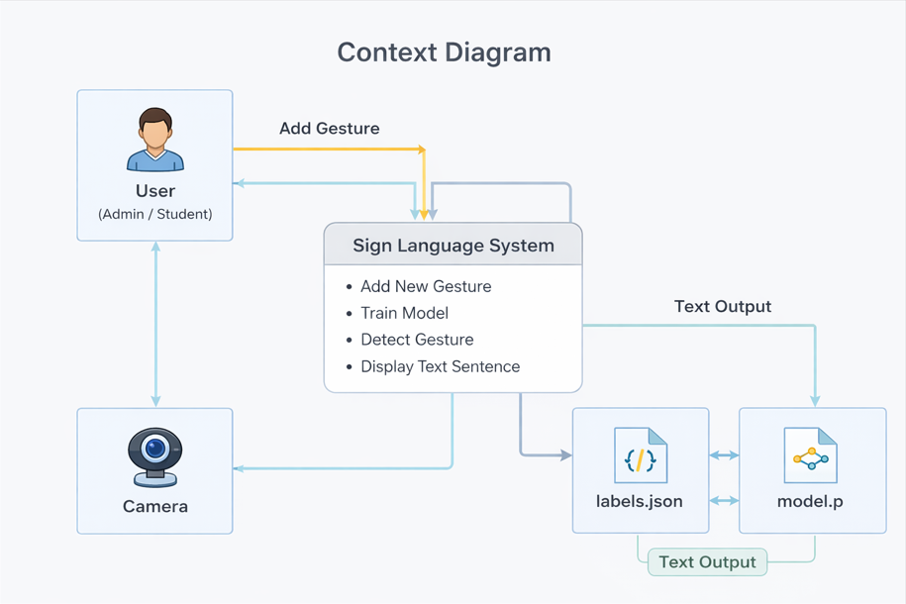
Context Diagram

2.1.1 DATA FLOW DIAGRAM:

This is data flow diagram level 0 of Sign language detection, where we have elaborated the processes of the system from a simplified perspective. It's a basic overview of the whole system and process while being analysed or modelled.

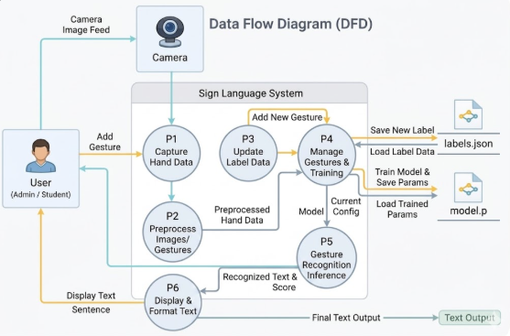

2.1.2 SYSTEM REQUIREMENTS:

- Python / SQL
- Camera / Device

2.1.2.1 Use-Case Diagrams

A use case diagram at its simplest is a representation of a user's interaction with the system that shows the relationship between the user and the different use cases in which the user is involved. A use case diagram can identify the different types of users of a system and the different use cases and will often be accompanied by other types of diagrams as well.
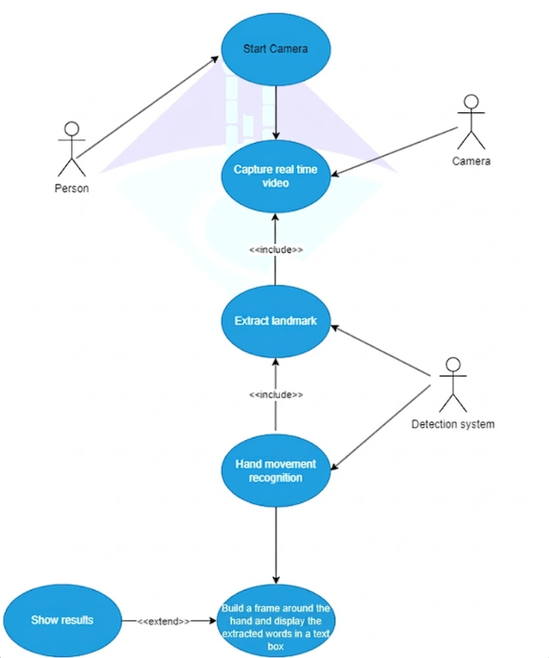
Figure 2.7: Use case diagram for sign language detection

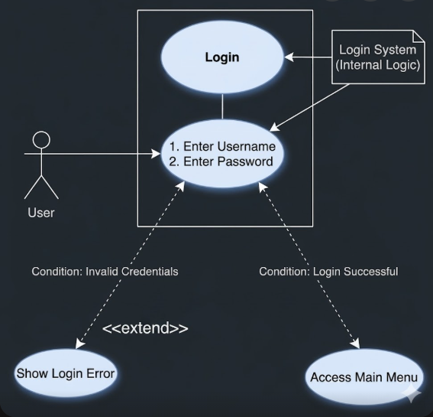

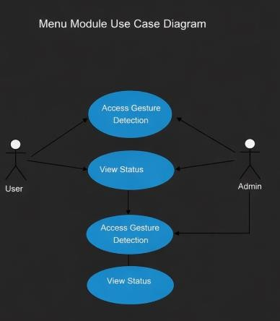

Title | Opening Sign language Detection System.
Actor | Person.
Description | The Person enters the system.
Normal Course | 3. The Person turns on the device.
Pre-Condition | - The user should use his hands in a clear manner.  - The user should have a positive balance to use the system.
Post-Condition | The driver should be always awake now.
Title | Sign language Detection System.
Actor | Detection System.
Description | The system detects the features of the hands "fingers" especially.
Normal course | 1.  The system uses the CNNs algorithm to recognize the  features of the hand.  2.  Once the hand landmarks are estimated in the first frame,  MediaPipe applies a tracking algorithm to track the hand  landmarks across subsequent frames.  3.  The system builds a frame around the hand to provide results  periodically.  4.  The system display the extracted words in a text box.
Pre-condition | The system must be turned on and the hand brought close to the camera to start recognizing the hand movement.
Post-condition | The user must provide correct hand movements.

2.1.2.2 LIST OF FUNCTIONAL AND DATA REQUIREMNTS:

This section describes the main functional capabilities and the data requirements needed to ensure that the Sign Language Detection System Using AI operates correctly and efficiently.

A) Functional Requirements
The system must support the following functions:

1. User Authentication and Access Control
The system must provide a login interface that allows authorized users to enter the system using a valid username and password. Unauthorized login attempts must be rejected with an appropriate error message.

2. Camera Access and Real-Time Video Capture
The system must be able to access the user’s device camera to capture realtime video frames. Camera access is essential for both gesture dataset collection and live gesture detection.

3. Hand Detection and Landmark Extraction
The system must detect the user’s hand in the captured video frames and extract hand landmarks accurately using a computer vision method (MediaPipe Hands). This step is required to represent hand movement features in a structured form suitable for prediction.

4. Hand Movement Recognition (Gesture Classification)
The system must be able to recognize and classify hand gestures using a trained machine learning model. The predicted gesture label must correspond to a predefined sign meaning stored in the system.

5. Display Results on the User Interface
The system must display the recognition result clearly on the detection window, including:
- The predicted gesture name
- A visible bounding box around the detected hand (optional enhancement)

6. Text Collection and Display Feature

This system will be able to gather the words and sentences conveyed by deaf people using hand movements, and will then be displayed in a separate text box right above the webpage in real-time basis. This is meant to facilitate a more convenient visualization of the translations.

7. Add New Gesture and Model Training
The system must allow an authorized user to add a new gesture by entering
its name and meaning. After that, the system must run a training pipeline that collects data, extracts features, and retrains the model automatically.

B) Data Requirements
To operate correctly, the system requires managing the following data:

1. User Credentials Data
The system must store and validate login credentials (username and password) for authorized users.

2. Gesture Labels Data (labels.json)
The system must store each gesture label with its details, including:
- Gesture ID
- Gesture Name
- Gesture Description / Meaning

3. Gesture Dataset Images (data folder)
The system must save captured gesture images for training purposes inside the project storage structure (e.g., data/<gesture_id>/).

4. Extracted Feature Dataset (data.pickle)
The system must store extracted hand landmark features and their corresponding labels to prepare the training dataset.

5. Trained Model File (model.p)
The system must generate and save the trained machine learning model to be reused during real-time detection.

2.1.2.3 LIST OF NON- FUNCTIONAL REQUIREMNTS:
Non-functional requirements describe the quality attributes and constraints that ensure the Sign Language Detection System Using AI performs efficiently and provides a satisfactory user experience. These requirements focus on usability, reliability, performance, compatibility, and system clarity.

1. Clarity and User Interface Design
The system interface should be clear, organized, and visually simple. All buttons, labels, and messages must be understandable, allowing users to interact with the system without confusion. Status messages (such as training progress and system state) should be displayed in a clear and readable format.

2. Usability
The system should be easy to use and manage, even for users with limited technical experience. Users must be able to:
- Log in easily using simple authentication.
- Navigate through the menu without complexity.
- Start gesture detection with one click.
- Add and train new gestures through guided steps.
The system must provide user-friendly alerts and instructions during operations such as collecting data and training the model.

3. Reliability
• Invalid login attempts. • Camera access failure.
The system should be reliable and stable during operation. It must be able to run
continuously without crashing or unexpected interruptions. In addition, the system
should handle errors properly, such as:

•

Missing training files (model or labels).

•

Training process interruptions.

Whenever an error occurs, the system should display clear and helpful error
messages rather than stopping silently.

4
. Compatibility and Portability

The system should be compatible with common computing devices that support Python, such as Windows-based laptops and desktops. Since the proposed solution is camera-based, it should work on any device that contains a functional camera or supports external webcam connections.
Additionally, the system should be portable and easy to install, requiring only standard Python libraries and dependencies without the need for expensive hardware such as sensors or gloves.

5. Performance (Real-Time Response)
The system should provide real-time gesture recognition with minimal delay between the gesture and the displayed result. The detection process must maintain smooth camera performance and produce stable predictions suitable for practical usage.

2.1.2.3.1 Look and feel requirements

The system interface should have a simple and clean design that is easy to understand. It should feel approachable and user-friendly so that users can operate it confidently without hesitation. In addition, the interface should appear professional and reliable, providing clear messages and feedback to build user trust. The system should also maintain a safe and comfortable user experience by displaying clear instructions and preventing confusing actions during training and detection.

2.1.2.3.2 USABILITY REQUIREMENTS:

The Sign Language Detection System should be easy to use and efficient. Users must be able to log in, access the menu, start gesture detection, and add new gestures with minimal steps. The system should provide clear buttons, readable labels, and helpful alerts when needed.

2.1.2.3.3 SECURITY REQUIREMENTS:

The Sign Language Detection System should be easy to use and efficient. Users must be able to log in, access the menu, start gesture detection, and add new gestures with minimal steps. The system should provide clear buttons, readable labels, and helpful alerts when needed.

2.1.2.3.4 PERFORMANCE REQUIREMENTS:

The system should operate smoothly in real time with minimal delay between gesture movement and recognition output. It does not require an internet connection because it runs offline. The system requires a device with a functional camera for detection.
2.1.2.3.5 PORTABILITY REQUIREMENTS:

The system should be portable and run on standard computers that support Python and have access to a camera. It should work on most medium-spec devices without requiring specialized hardware, making it suitable for different environments and user needs.

2.1.3 CLASS DIAGRAM:

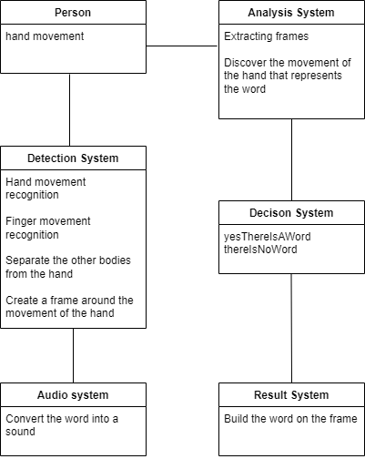
Figure 2.8: Class diagram for sign language detection

2.1.4 PROPOSED SOLUTIONS:

The main issue addressed by this project is the communication gap between individuals with hearing and speech impairments and the rest of society. To solve this problem, we propose a Sign Language Detection System Using Artificial Intelligence (AI) that recognizes hand gestures and translates them into readable words in real time.
The proposed system is camera-based and operates offline, making it cost-effective and easy to use. It captures live video, extracts hand landmarks using computer vision techniques, and applies a trained machine learning model to identify the performed gesture. The final output is displayed clearly on the user interface, supporting better understanding and improving communication.

2.1.5 ALTERNATIVE SOLUTIONS:

Although the current system is implemented as a desktop application using Python, the same concept can be developed using other platforms to reach a wider audience:

1. Mobile Application
The system could be implemented as a mobile application using technologies such as Flutter, Kotlin, Android Studio, or React Native. This would allow users to perform gesture detection using smartphone cameras and enable more portable usage.

2. Web-Based Application
The system could also be developed as a web application, where the user interface runs through a browser. This approach would make the system accessible from different devices without installing a desktop program, and it could be extended later for cloud-based features if needed.

CHAPTER 3
- DESIGN CONSIDERATIONS:
3.1 DESIGN CONSTRAINTS:

- Time: Learn how to open camera, install different libraries like dlib, OpenCV, threads, etc. and their functions.
- Resources: Choosing the best and correct version of Python to use all the libraries we need in the project.
- Standards: Python is the primary source code for our application.
- Earlier Coursework: During our studies at the computer science department, we have taken some classes that helped us in the:
▪ Python courses: these courses were necessary to build project and choose specific libraries to help us with it.
▪ Operating System courses: these courses helped us on how to perform and use the multi-tasking using threads.
▪ Problem Solving: this course helped us to define the problem, prepare a plan to solve the problem and specify the steps.

3.1.1 HARDWARE AND SOFTWARE ENVIRONMENT:

We did our best to give the user the easiest and best use of the system, there must be a camera to detect the contours of the hand and fingers, it determines what word rewards this movement using certain algorithms such as CNNs.

3.1.2 END USER CHARACTERISTICS:

When we thought of the sign language detection system, it was for deaf and dumb people. The user or actor in this scenario must place the camera in an area where the camera can detect the user's hand.

3.2 ARCHITECTURAL STRATEGIES:

3.2.1 ALGORITHMS TO BE USED:

The core functionality of the proposed system depends on detecting hand gestures by extracting hand landmarks and then applying a machine learning model to classify the performed sign. The system uses a combination of computer vision and machine learning libraries to achieve real-time performance and accurate recognition.

MediaPipe Hands (Landmark Detection)
The system uses the MediaPipe Hands solution to detect the user’s hand and extract a set of 21 hand landmarks. These landmarks represent key points such as finger joints and fingertips, allowing the system to describe the hand shape in a structured and measurable form. MediaPipe is efficient and works in real time, making it suitable for live gesture detection.

OpenCV (Video Capture and Image Processing)
The OpenCV library is used to access the device camera and capture video frames continuously. It also provides essential image processing operations such as converting color formats, enhancing frames, drawing bounding boxes, and displaying the final output window. OpenCV plays an important role in creating a smooth real-time detection experience.

Scikit-learn (Machine Learning Classification)
For gesture classification, the system uses the Scikit-learn (Sklearn) library, which provides a set of machine learning algorithms used to build predictive models from the collected dataset. In this project, a classification model is trained using extracted hand landmark features, enabling the system to recognize gestures and map them to their corresponding labels.

Recognition and Output Process
After extracting the landmarks, the system normalizes the landmark coordinates and converts them into a feature vector that represents the gesture. This feature vector is passed to the trained model to predict the gesture class in real time. Once a gesture is recognized:
- A bounding box is drawn around the detected hand.
- The predicted gesture label is displayed above the box.
- The system can collect and display the words extracted from hand gestures in a text box to provide additional support for communication.
Overall, the integration of MediaPipe for landmark extraction, OpenCV for real-time video processing, and Scikit-learn for classification allows the system to detect and translate sign language gestures efficiently and accurately.

Example:
If the user approaches the camera and makes a certain movement in his fingers
indicating that he is hungry, the system will, in real time, show the word above the
frame and then make the system display the extracted words in a text box.

3.2.2 PROJECT MANAGEMENT STRATEGIES:

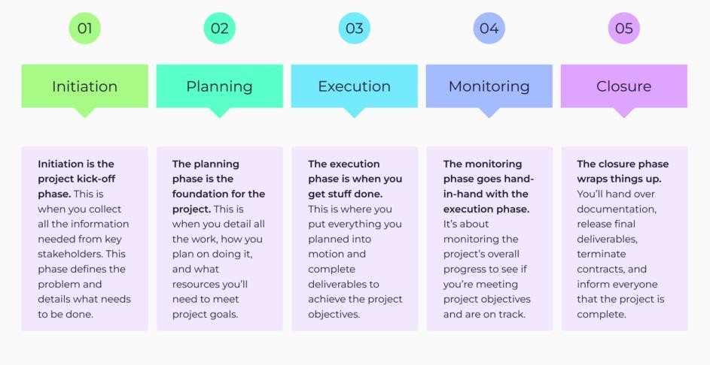

Figure 2.9: Project Management

3.2.3

DEVELOPMENT

METHOD:

The system was developed using a combination of scrum and extreme
programming methods, which are both agile approaches. The system was divided
into small modules that were developed and tested separately and then integrated.
Refactoring was applied during
unit testing to optimize the modules for their
functionality.

3.2.4 FUTURE ENHANCEMENTS/ PLANS:

- The expected future of our project is to provide the advantage in many wellknown applications by building partnerships with these companies.

- Increase the diversity of data by merging a large variety of data to increase the program's coverage of a greater amount of words and increase the accuracy of the results

CHAPTER 4
- System Design:
  - ARCHITECTURE AND PROGRAM FLOW:

General Program Flow Diagram:
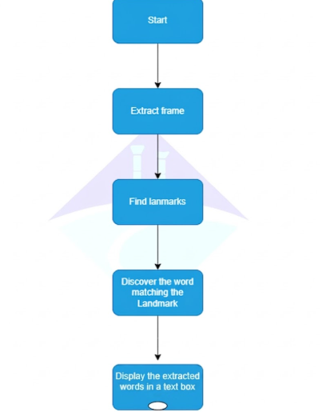

Figure 3.0: Program flow diagram for sign language detection

4.1.2 SUB MODULES:

Hand Detection:
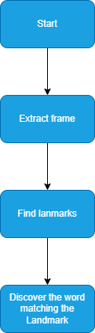

Figure 3.1: Program flow diagram for sign language detection

Collect and display extracted words:
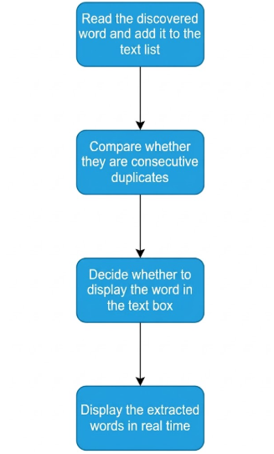
Figure 3.2: Program flow diagram for sign language detection

CHAPTER 5
- implementation and validation
  - IMPLEMNTATION:

The system captures live video frames directly from the device camera using the OpenCV library. Every frame is analyzed to detect the hand of the user and recognize the gesture performed in real time.
After that, during recognition, the system uses a lightweight image enhancement layer (sharpening and contrast enhancement) in the scene to improve the visual resolution of the feature image, so as to promote the landmark detection. Hand Tracking: This system monitors only one hand using MediaPipe Hands, which computes 21 hand landmarks (the “key points”) comprising finger joints and fingertip regions.
Now we extract these landmarks as normalized coordinates to prepare a feature vector for classification. The system first collects the (x, y) values for each landmark, normalizes such landmarks by subtracting the minimum x and y values, and outputs 42 fixed-length input (21 landmarks × 2 coordinates).
The trained machine learning model (Random Forest) predicts the gesture class after determining its features.
The class ID of the predicted user is then assigned to a semantic gesture name, represented by the dynamic labels file (labels.json).
The result is reflected in the output by placing a bounding box around the detected hand and displaying the predicted gesture label above that bounding box as it occurs.
To stabilize and prevent flickering predictions, the system performs a smoothing step by holding few previous predictions in a buffer and taking the result of the most frequently occurred predictions.
The detection is continuous until the user presses the exit key (0), which automatically closes the camera window and concludes execution.
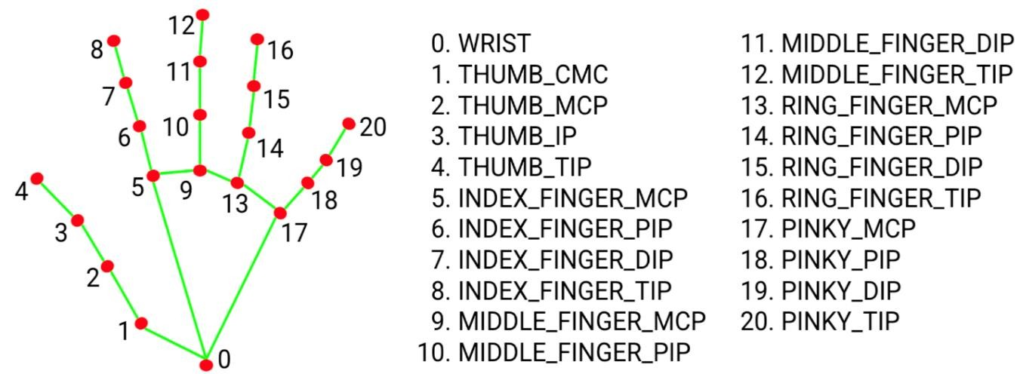

- Detection: The initial step in the process involves the identification of the hand. To achieve this, a model for recognizing the palm is used - a model functioning as a oneshot detector and bearing similarities to MobileNets. The primary function of this model is to identify the hand within the image, and it is designed to execute in real-time.
Figure 3.3: Landmark for sign language detection

Task inputs

Task outputs

The Hand Landmarker accepts an input of one
of the following data types:

The Hand Landmarker outputs the following
results:

Still images

Handedness of detected hands

Decoded video frames

Landmarks of detected hands in image
coordinates

Live video feed

Landmarks of detected hands in world
coordinates

How does the mediapipe library work inside the project:

- Identifying Crucial Landmarks: Once the hand is successfully recognized, the subsequent phase is to ascertain the locations of significant points of reference on the hand. The MediaPipe Hands system leverages a model specific to hand landmarks. This model processes the Region of Interest (ROI) obtained from the palm recognizer and generates 3D coordinates for important points on the hand. These points are 21 in total, encompassing the palm, thumb, and all the fingers - index, middle, ring, and little.

- Monitoring: The previously identified important points on the hand from the preceding image frame are employed to evaluate the region of significance for the forthcoming frame. This process effectively sidesteps the necessity for additional palm detection, unless the tracked hand is no longer discernible, which is to say, the assurance dips below a set limit. By reutilizing crucial points from the earlier frame for tracking, both operational efficiency and performance receive a boost.

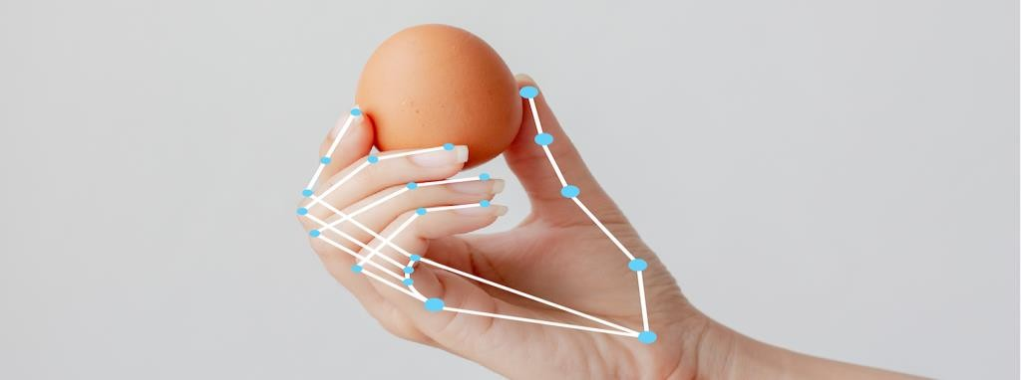

Figure 3.4: Landmark for sign language detection

5.2

VALIDATION:

5.2.1

V
ALIDATION
C
RITERIA
:

- Accuracy: Measure the system's ability to correctly recognize and interpret sign language gestures. This can be assessed by calculating the percentage of correct predictions or by using evaluation metrics such as precision, recall, and F1 score.

- Real-time Responsiveness: Evaluate the system's ability to provide timely and immediate feedback or response to the user's sign language gestures. Measure the latency or response time of the system to ensure it meets real-time requirements.

5.2.1 VALIDATION CRITERIA:

  - Data Collection:

    - Gather a diverse dataset of sign language gestures, capturing various hand movements, finger configurations, and signs.
    - Ensure the dataset represents a range of users with different hand sizes, skin tones, and signing styles.
    - Use Mediapipe's hand tracking functionality to capture hand movement data, along with any other necessary sensors or devices.

  - Preprocessing:
Preprocess the collected data to remove noise, correct for lighting conditions, and
enhance the quality of the hand movement data.

Utilize OpenCV for image processing techniques such as noise reduction,
normalization, and feature extraction.

Perform any necessary data transformations, such as resizing or resampling, to
prepare the data for further analysis.

  - Feature Extraction:

    - Extract relevant features from the preprocessed hand movement data.
    - Use techniques such as contour analysis, landmark detection, or motion tracking to identify key characteristics of the hand movements.
    - Consider features such as hand shape, finger positions, relative distances, or movement trajectories.

  - Model Training:

    - Split the preprocessed data into training and validation sets.
    - Utilize machine learning algorithms from scikit-learn, such as decision trees, random forests, or support vector machines, to train the sign language detection model.
    - Optimize model parameters through techniques such as grid search or crossvalidation.
    - Evaluate the model's performance using appropriate metrics, such as accuracy, precision, recall, or F1 score.

5. Evaluation:

- Test the trained model on a separate testing dataset or with real-world examples.
- Assess the system's accuracy in recognizing and interpreting sign language gestures.
- Evaluate the real-time responsiveness of the system, measuring the latency or response time from gesture input to system output.

5.2.1 DATA COLLECTION:

Capturing Hand Movements:
- OpenCV was used to capture video frames from a camera source.
- The system captured 100 frames per 5 seconds to ensure a sufficient number of samples for each gesture.

Hand Tracking with Mediapipe:
- Mediapipe's hand tracking functionality was utilized to track the hand movements in each frame.
- The hand tracking module provided by Mediapipe detects and localizes the hand
● landmarks, including finger tips, palm center, and other important hand features.

Data Diversity and Representativeness:
- Considerations were made to ensure diversity and representativeness of the sign language gestures in the dataset.
- Multiple individuals with different hand sizes, skin tones, and signing styles were included in the data collection process.
- Gestures covering a wide range of signs, finger configurations, and hand movements were captured to make the dataset comprehensive and inclusive.

Sample Size:
- The dataset's sample size was determined based on the number of distinct sign language gestures intended to be recognized by the system.
- Sufficient samples were collected for each gesture to provide an adequate training representation and improve the system's ability to generalize.

REFERENCES (APA 7TH EDITION)
Google. (n.d.). MediaPipe documentation. https://developers.google.com/mediapipe
Python Software Foundation. (n.d.). pickle — Python object serialization. Python 3
Documentation. https://docs.python.org/3/library/pickle.html
Wikipedia contributors. (n.d.). Sign language. Wikipedia. https://en.wikipedia.org/wiki/Sign_language
OpenCV Team. (n.d.). OpenCV documentation. https://docs.opencv.org/4.x/
scikit-learn developers. (n.d.). scikit-learn: Machine learning in Python (documentation). https://scikit-learn.org/stable/
Javatpoint. (n.d.).
Random forest algorithm in machine learning
.
https://www.javatpoint.com/machin
e
-
learnin
g
-
rando
m
-
fores
t
-
algorith
m

